**Knowledge Representation & Reasoning**

1. **What is KKR? Why KKR is needed in A.I?**

Knowledge Representation is a field of artificial intelligence that is concerned with presenting real-world information in a form that the computer can 'understand' and use to 'solve' real-life problems or 'handle' real-life tasks.

It is a way that describes how we can represent knowledge in artificial intelligence.  Knowledge representation is not just storing data into some database, but it also enables an intelligent machine to learn from that knowledge and experiences so that it can behave intelligently like a human.

1. **Definition of PL (Propositional Logic), PDL(Predicate Logic), and FL(Fuzzy Logic).**

**Propositional logic (PL)** is the simplest form of logic where all the statements are made by propositions. A proposition is a declarative statement that is either true or false. It is a technique of knowledge representation in logical and mathematical form.

**Predicate Logic (PDL)** deals with predicates, which are propositions, consist of variables. It is a powerful language that develops information about the objects in a more easy way and can also express the relationship between those objects.

**Fuzzy Logic (FL)** in artificial intelligence is a generalized form of standard logic, where any concept might have a truth degree ranging between 0.0 and 1.0.

1. **What are the different types of inferences that are used on the above 3 types of knowledge representation techniques with examples?**

**Propositional logic (PL)**

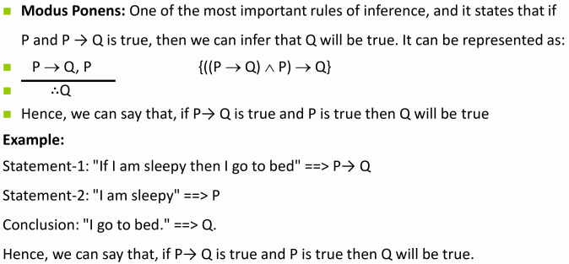

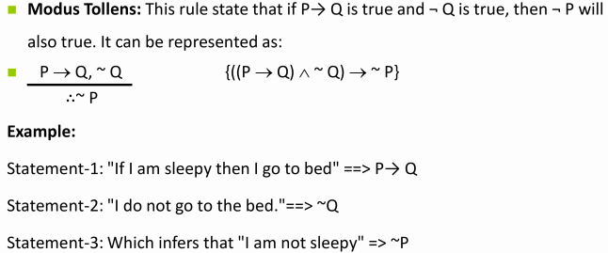

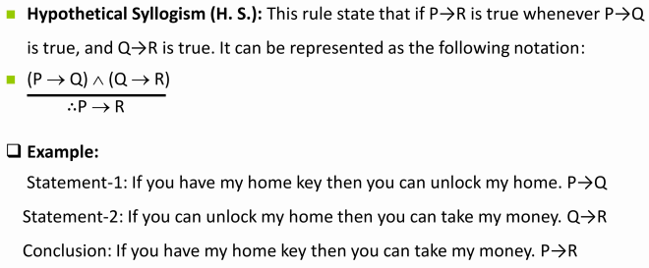

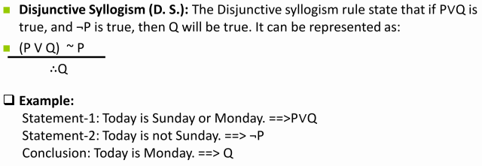

**♦ Drawbacks of PL -**

1. Has limited expressive power
2. No representation to relations like “All, some, none, etc”
   1. E.g All eggs are rotten, some apples are sweet, etc.
3. Alternate = Predicate Logic

**Predicate Logic (PDL)**

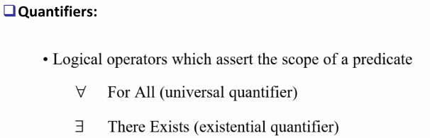

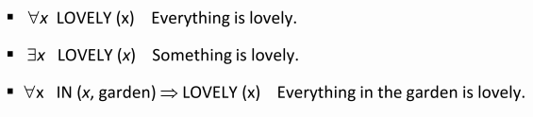

**Fuzzy Logic (FL)**

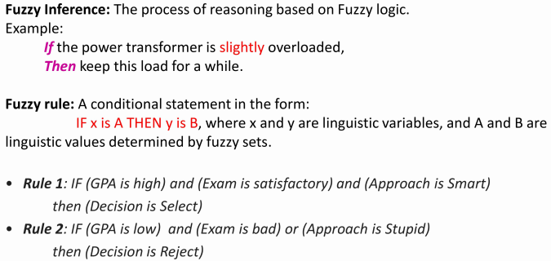

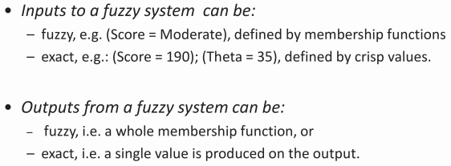

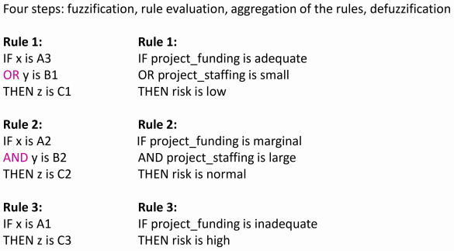

1. **Symbols, quantifiers, rules of inference in different types of knowledge representation technique with examples.**

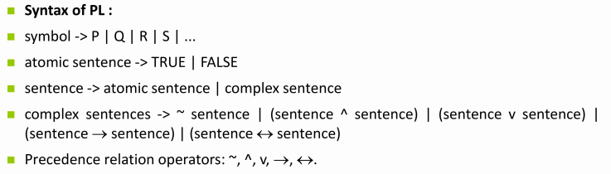

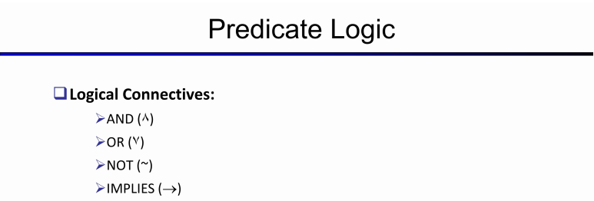



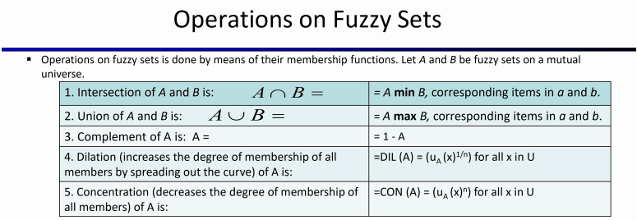

1. **Difference between Fuzzy Logic and Crisp Logic. What are fuzzy expert systems?**

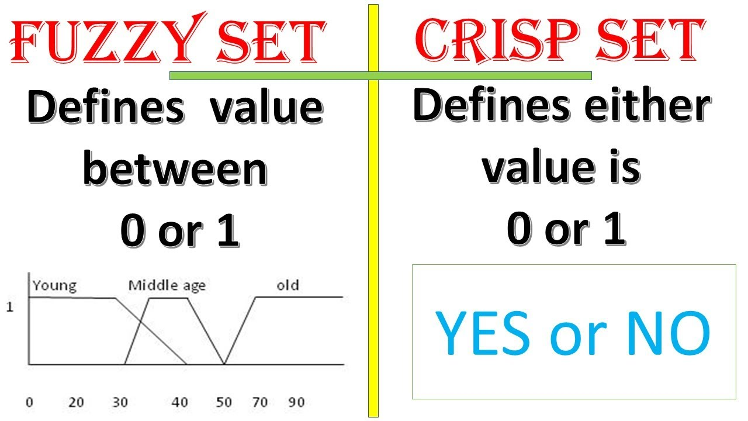

Crisp logic (crisp) is the same as boolean logic(either 0 or 1). Either a statement is true(1) or it is not(0), meanwhile fuzzy logic captures the degree to which something is true.

A fuzzy expert system is an expert system that uses fuzzy logic instead of Boolean logic. In other words, a fuzzy expert system is a collection of membership functions and rules that are used to reason about data. A typical fuzzy expert system has more than one rule.

1. **Application of PL, PDL & FL**

**Propositional Logic - Design of computing machines, artificial intelligence, the definition of data structures for programming languages, etc.**

**Predicate Logic - Formal notations for writing clear and concise mathematical definitions.**

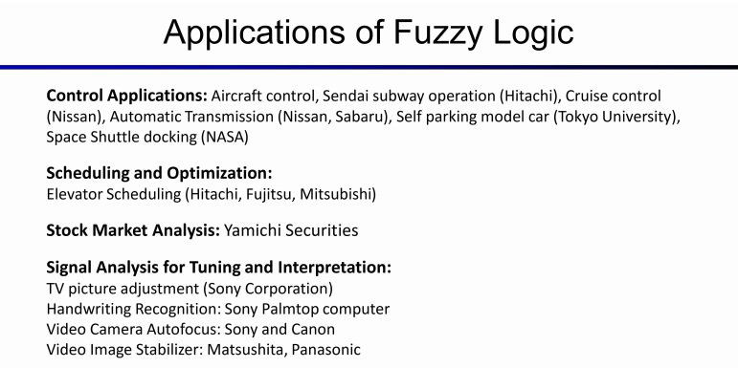

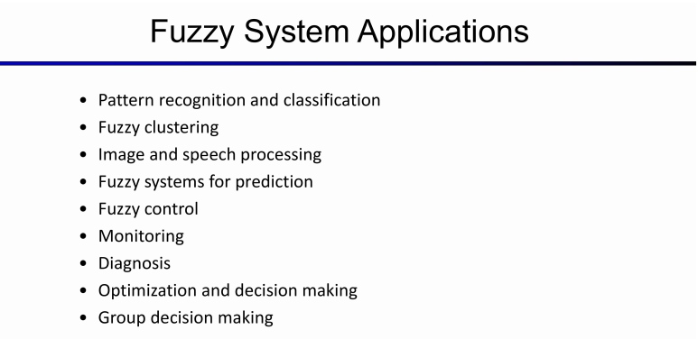

1. **Limitations of PL, PDL & FL**

**Limitations of PL -**

1. Has limited expressive power
2. No representation to relations like “All, some, none, etc”
   1. E.g All eggs are rotten, some apples are sweet, etc.
3. Alternate = Predicate Logic

**Limitations of PDL -**

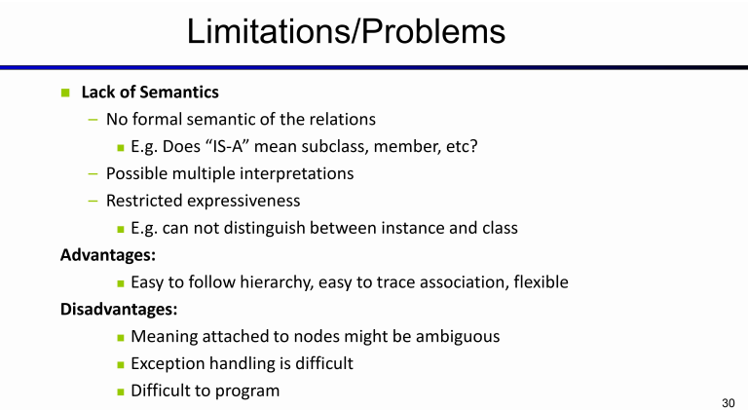

**Disadvantages of Fuzzy Logic Systems -**

1. **Fuzzy logic is not always accurate, so The results are perceived based on assumption, so it may not be widely accepted.**
2. **Fuzzy systems don't have the capability of machine learning as well as neural network type pattern recognition.**

**A major drawback of Fuzzy Logic control systems is that they are completely dependent on human knowledge and expertise.**